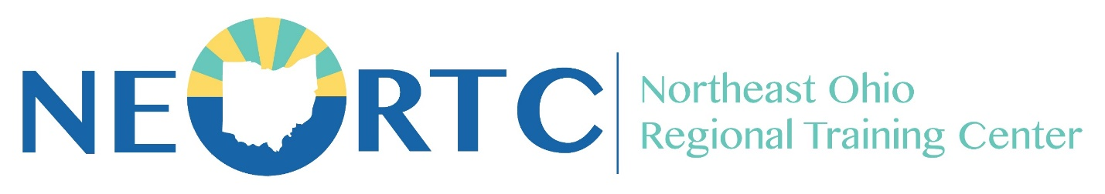
PRESERVICE TRAINING

IN PERSON @ LORAIN
226 Middle Avenue, Elyria, OH 44035

Saturday, February 24, 2024
- Basics of Placement 9:00am-11:30pm
- Trauma Overview 12:00pm-1:30pm
- The Impact of Trauma on Children in Care 1:45pm-3:15pm
Saturday, March 2, 2024
- Permanency 9:00am-10:00am
- Maintaining the Child’s Connections 10:15am-11:45am
- Partnering with the Primary Families 12:15pm-1:45pm
- Effects of Caregiving 2:00pm-4:00pm
Saturday, March 16, 2024
- Child Development 9:00am-11:00pm
- Adolescent Development 11:15pm-12:15pm
- Diversity Foundations 12:45pm-2:15pm
- Discipline Foundations 2:30pm-4:30pm

Instructor: Beth Cardina
REGISTRATION IS STILL OPEN
Visit CAPS LMS

NEORTC Training Coordinator: Cindy Wallis Contact: Cynthia.Wallis@summitkids.org

